Circle Language Spec: System Objects

Pointer Assignments
Next to assigning one object reference’s object to another object reference, you could also assign the object reference itself to another object reference. In that case the second object reference will become a reference to an object reference, instead of a reference to an object. This requires another type of assignment: a pointer assignment.

Pointer assignments establish a pointer-to-pointer. Instead of assigning a target object to the reference, you assign a reference to the reference. This creates a pointer-to-pointer, instead of a direct reference to an object. This allows another object reference to decide which object is eventually pointed at.

A pointer assignment always has a Reference as a source, not its Object, not its Class, but the Reference itself.

A pointer assignment is displayed with an arrow inside the diamond.

Object Pointer Assignment:
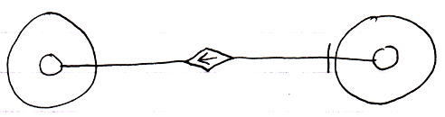
Reference Get ←
Object Set → (~= Set Object to Other Related Item)
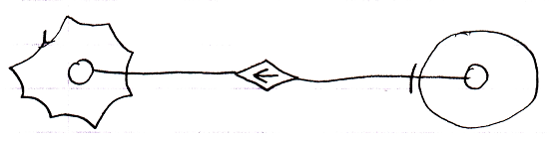
Reference Get ←
Object Set → (~= Set Object to Other Related List Item)
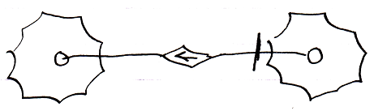
Reference Get ←
Object Set → (~= Set Object to Other Related List Item)

Pointer assignment also works for class assignment. You can use a reference as a class, instead using an object itself as the class:

Class Pointer Assignment:
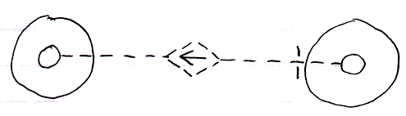
Use Reference As Class ← (~= Reference Get)
Class Set → (~= Set Class to Other Related Item)
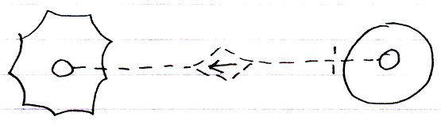
Use Reference As Class ← (~= Reference Get)
Class Set → (~= Set Class to Other Related Item)
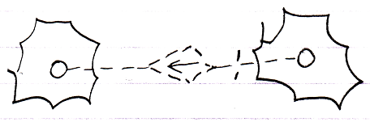
Use Reference As Class → (~= Reference Get)
Class Set → (~= Set Class to Other Related List Item)

